**PRACTICAL APPLICATION OF SOFTWARE DEVELOPMENT IN INDUSTRIES**

**(Report)**

Submitted by

**Name:**

**Matric Number:**

Computer Science Department

Lagos State University

February 2024

**Table of Contents:**

1. Introduction
2. Objectives
3. Technologies and Tools Used
4. Database Integration and CRUD Operations
5. Documentation and Submission
6. Conclusion
7. **Introduction:**

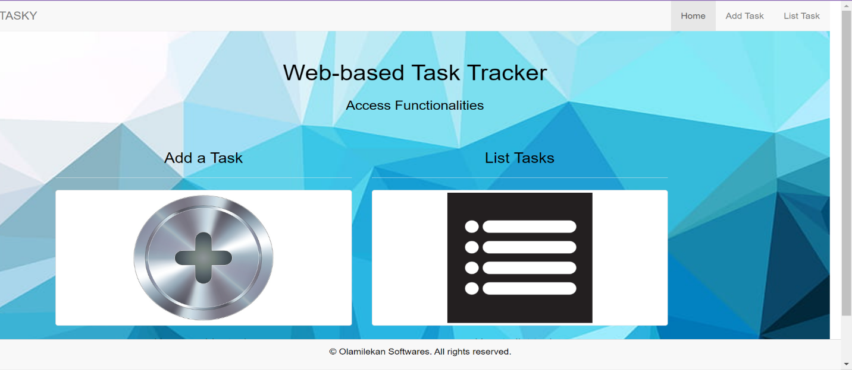The Web-based Task Tracker is a software package designed to assist users in managing their tasks efficiently. This report provides an overview of the development process, technologies used, and key functionalities of the task tracker application.

Homepage of the app

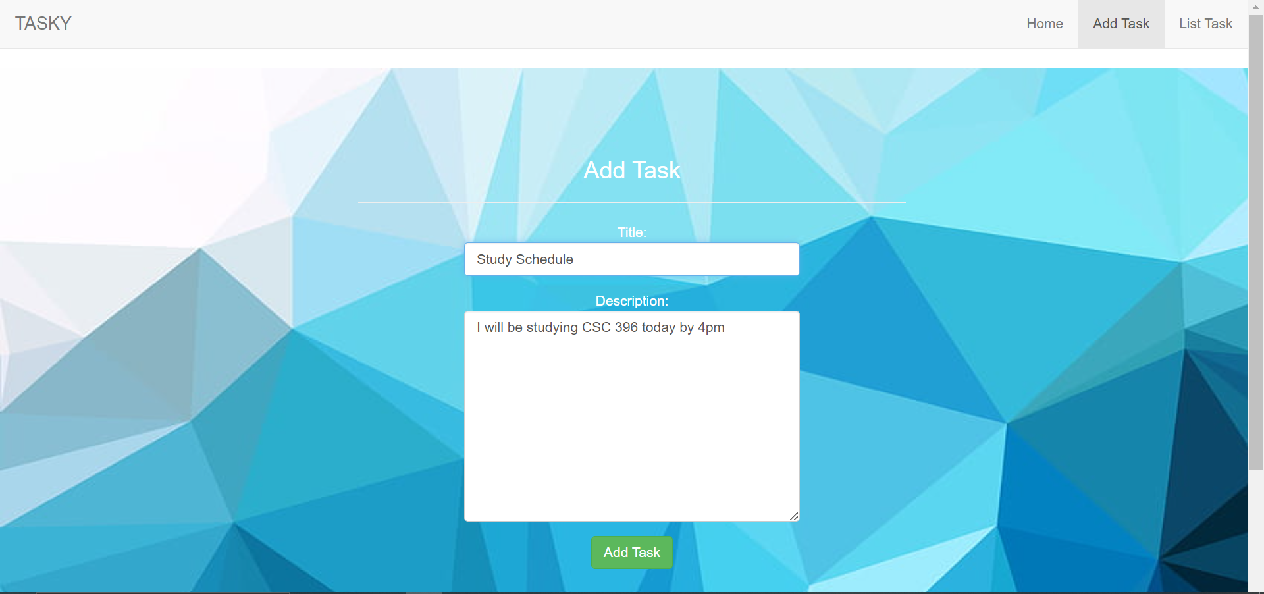

**2. Objectives:**

The main objective of developing the Web-based Task Tracker is to provide users with a simple yet effective tool for organizing their tasks. Specific objectives include:

* Allowing users to add, edit, and delete tasks.
* Providing a user-friendly interface for task management.
* Demonstrating understanding of software development principles and methodologies.
* Integrating database functionality for storing task data.

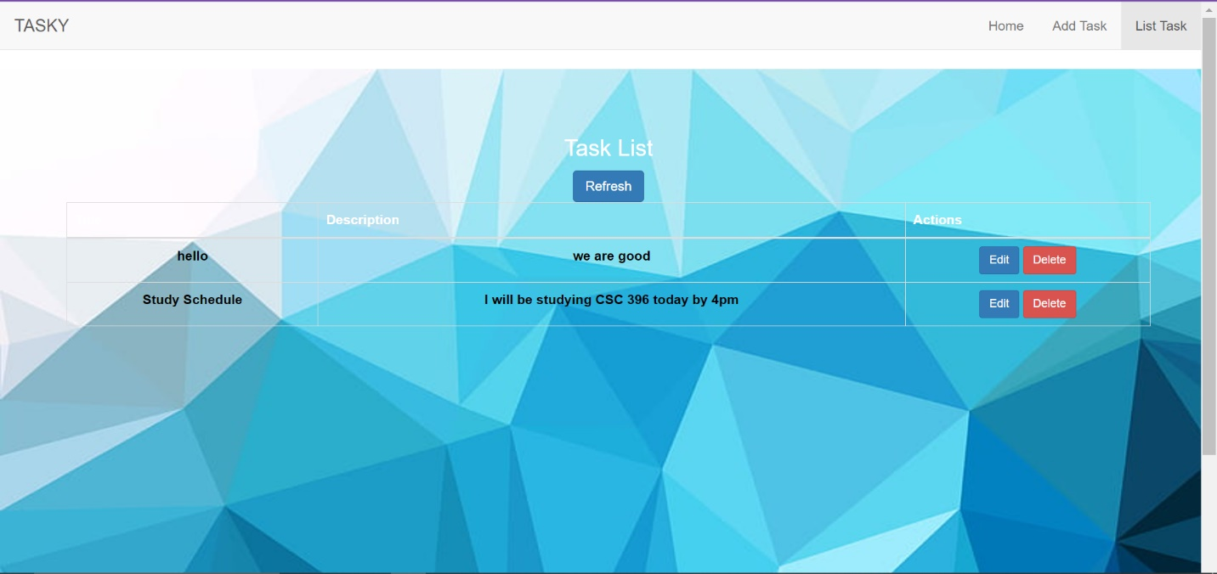

**3. Technologies and Tools Used:**

* HTML5, CSS3, Bootstrap: Front-end technologies for building the user interface.
* JavaScript (jQuery): Client-side scripting for interactivity and dynamic content.
* PHP: Server-side scripting language for backend logic and database interactions.
* MySQL: Relational database management system for storing and querying task data.
* WAMP (Windows, Apache, MySQL, PHP): Local server environment for testing and development.

**4. Database Integration and CRUD Operations:**

The Web-based Task Tracker integrates with a MySQL database to store task information. CRUD (Create, Read, Update, Delete) operations are performed on the database to manage tasks. This includes adding new tasks, retrieving task details, updating existing tasks, and deleting tasks as needed.

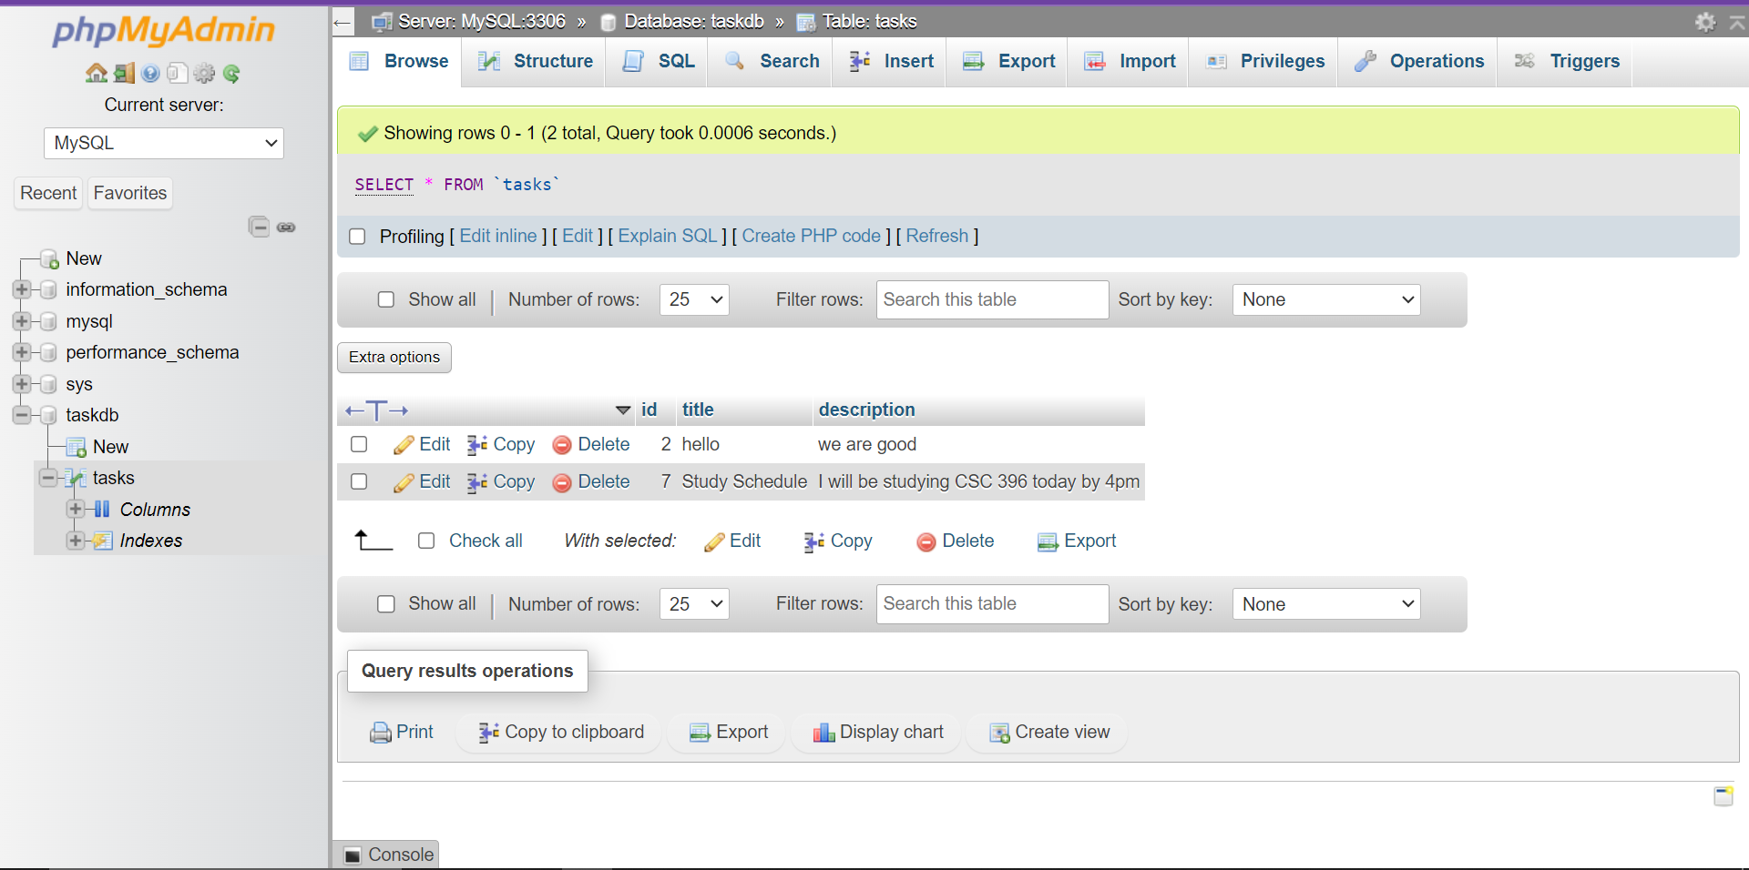

**5. Documentation and Submission:**

As part of the development process for the Web-based Task Tracker, comprehensive documentation has been meticulously prepared to facilitate seamless installation and usage. This personalized documentation package includes:

**Installation Guide:** Installing the Web-based Task Tracker is a straightforward process. Follow these steps to get started:

1. **Download the Project Files:**
   * Obtain the project files, including HTML, CSS, JavaScript, PHP scripts, and image assets.
   * Ensure all files are saved in a dedicated folder on your computer.
2. **Setup WAMP (Windows, Apache, MySQL, PHP):**
   * If not already installed, download and install WAMP from the official website.
   * Launch the WAMP server application on your local machine.
3. **Database Setup:**
   * Open phpMyAdmin from the WAMP control panel.
   * Create a new database named "taskdb" to store task data.
4. **Configure Database Connection:**
   * Open the "connection.php" file from the project folder in a text editor.
   * Update the database connection settings (hostname, username, password, database name) to match your WAMP configuration.
5. **Deploy the Application:**
   * Move the entire project folder into the "www" directory of your WAMP installation.
   * Access the application by navigating to "localhost/project_folder_name" in your web browser.

**Usage Guide:** Once the Web-based Task Tracker is successfully installed, follow these instructions to effectively utilize its features:

1. **Adding a Task:**
   * Click on the "Add Task" link in the navigation menu.
   * Fill out the title and description fields in the provided form.
   * Click the "Add Task" button to save the task.
2. **Listing Tasks:**
   * Navigate to the "List Task" page using the corresponding link in the navigation menu.
   * View all added tasks along with their titles and descriptions.
3. **Editing a Task:**
   * From the list of tasks, click on the "Edit" button next to the task you want to modify.
   * Update the title and description fields in the edit form.
   * Click the "Update" button to save the changes.
4. **Deleting a Task:**
   * To remove a task, click on the "Delete" button next to the task in the list.
   * Confirm the deletion when prompted.

This detailed documentation package ensures that users have all the necessary information to seamlessly install, configure, and utilize the Web-based Task Tracker for efficient task management. It will be submitted along with the software package for assessment and future reference.

1. **Conclusion:**

In conclusion, the Web-based Task Tracker is a valuable tool for task management, developed with adherence to software development principles and methodologies. By integrating database functionality, providing a user-friendly interface, the task tracker application meets the objectives of efficient task organization and demonstrates proficiency in software development techniques.